ASSIGNMENT - 6.4

Hall Ticket No: 2303A51603
Name : N.Anil Yadav

Lab 6: AI-Based Code Completion – Classes, Loops, and Conditionals

Lab Objectives:
Week1 -
Wednesday
The objectives of this lab are to:
• To explore AI-powered auto-completion features for core Python
constructs.
• To analyze how AI suggests logic for class definitions, loops, and
conditionals.
• To evaluate the completeness and correctness of code generated by AI
assistants.
Lab Outcomes (LOs):
• After completing this lab, students will be able to:
• Use AI tools to generate and complete class definitions and methods.
• Understand and assess AI-suggested loops for iterative tasks.
• Generate conditional statements through prompt-driven suggestions.
• Critically evaluate AI-assisted code for correctness and clarity.

Task 1: Student Performance Evaluation System:

Scenario
You are building a simple academic management module for a university
system where student performance needs to be evaluated automatically.
Task Description
Create the skeleton of a Python class named Student with the attributes:
• name
• roll_number
• marks
Write only the class definition and attribute initialization.
Then, using GitHub Copilot, prompt the tool to complete:
• A method to display student details
• A method that checks whether the student’s marks are above the
class average and returns an appropriate message
Use comments or partial method names to guide Copilot for code
completion.

Prompt:
Create a Python class named Student with attributes name, roll_number, and marks.
I have already written the __init__ method.
Using if-else conditions and self attributes:
1. Complete a method to display student details.
2. Complete another method that checks whether the student's marks are above the class average and returns an appropriate message.
Use clean formatting and beginner-friendly Python code.
Also include a small example showing the output.

Expected Outcome:
• A completed Student class with Copilot-generated methods
• Proper use of:
o self attributes
o Conditional statements (if-else)
• Sample output showing student details and performance status

Task 2: Data Processing in a Monitoring System
Scenario:
You are working on a basic data monitoring script where sensor readings
are collected as numbers. Only even readings need further processing.
Task Description:
Write the initial part of a for loop to iterate over a list of integers
representing sensor readings.
Add a comment prompt instructing GitHub Copilot to:
• Identify even numbers
• Calculate their square
• Print the result in a readable format
Allow Copilot to complete the remaining loop logic.

Prompt:
I have a list of integers representing sensor readings.
Complete a Python for loop that:
1. Iterates through the list
2. Identifies even numbers using the modulus operator
3. Calculates the square of each even number
4. Prints the result in a readable format like:
"Even reading X -> square: Y"
Use conditional statements and keep the code simple.

Expected Outcome
• A complete for loop generated by Copilot
• Use of:
o Modulus operator to identify even numbers
o Conditional statements
• Correct and formatted output for valid inputs

Task 3: Banking Transaction Simulation
Scenario:
You are developing a basic banking module that handles deposits and
withdrawals for customers.

Task Description:

Create the structure of a Python class named BankAccount with
attributes:
• account_holder
• balance
Use GitHub Copilot to complete methods for:
• Depositing money
• Withdrawing money
• Preventing withdrawals when the balance is insufficient
Guide Copilot using method names and short comments.
Prompt:
Create a Python class named BankAccount with attributes account_holder and balance.

Using class methods and if-else conditions:
1. Complete a deposit method that adds money to the balance
2. Complete a withdraw method that subtracts money only if sufficient balance is available
3. Print user-friendly messages for successful and failed transactions

Include a small demo showing deposit, withdrawal, and insufficient balance handling.

Expected Outcome:
• A fully functional BankAccount class
• Copilot-generated methods using:
o if-else conditions
o Class attributes via self
• Proper handling of invalid withdrawal attempts with user-friendly messages

Task 4: Student Scholarship Eligibility Check
Scenario
A university wants to identify students eligible for a merit-based
scholarship based on their scores.
Task Description
Define a list of dictionaries where each dictionary represents a student
with:
• name
• score
Write the initialization and list structure yourself.
Then, prompt GitHub Copilot to generate a while loop that:
• Iterates through the list
• Prints the names of students who scored more than 75
Use comments to guide Copilot’s code completion.

Prompt:
I have a list of dictionaries where each dictionary represents a student
with keys: name and score.

Using a while loop:
1. Iterate through the list
2. Check which students have a score greater than 75
3. Print the names and scores of eligible students in a clean format

Use correct index handling and simple Python syntax.

Expected Outcome
• A complete while loop generated by Copilot
• Correct index handling and condition checks
• Cleanly formatted output listing eligible students

Task 5: Online Shopping Cart Module
Scenario:
You are designing a simplified shopping cart system for an e-commerce
website that supports item management and discount calculation.
Task Description
Begin writing a Python class named ShoppingCart with:
• An empty list to store items (each item may include name, price,
quantity)
Use GitHub Copilot to generate methods that:
• Add items to the cart
• Remove items from the cart
• Calculate the total bill using a loop
• Apply conditional discounts (e.g., discount if total exceeds a
certain amount)
Use meaningful comments and method names to guide Copilot.

Prompt:
Create a Python class named ShoppingCart with an empty list to store items.
Each item should have a name, price, and quantity.

Using loops and conditional statements:
1. Complete a method to add items to the cart
2. Complete a method to remove or decrease item quantity
3. Complete a method to calculate the total bill using a loop
4. Apply a discount if the total exceeds a certain amount

Include a sample demonstration showing item addition, removal, and final bill calculation.

Expected Outcome
• A fully implemented ShoppingCart class
• Copilot-generated loops and conditional logic
• Correct handling of item addition, removal, and discount
calculation
• Sample input/output demonstrating cart functionality
Note: Report should be submitted a word document for all tasks in a single

CODE:

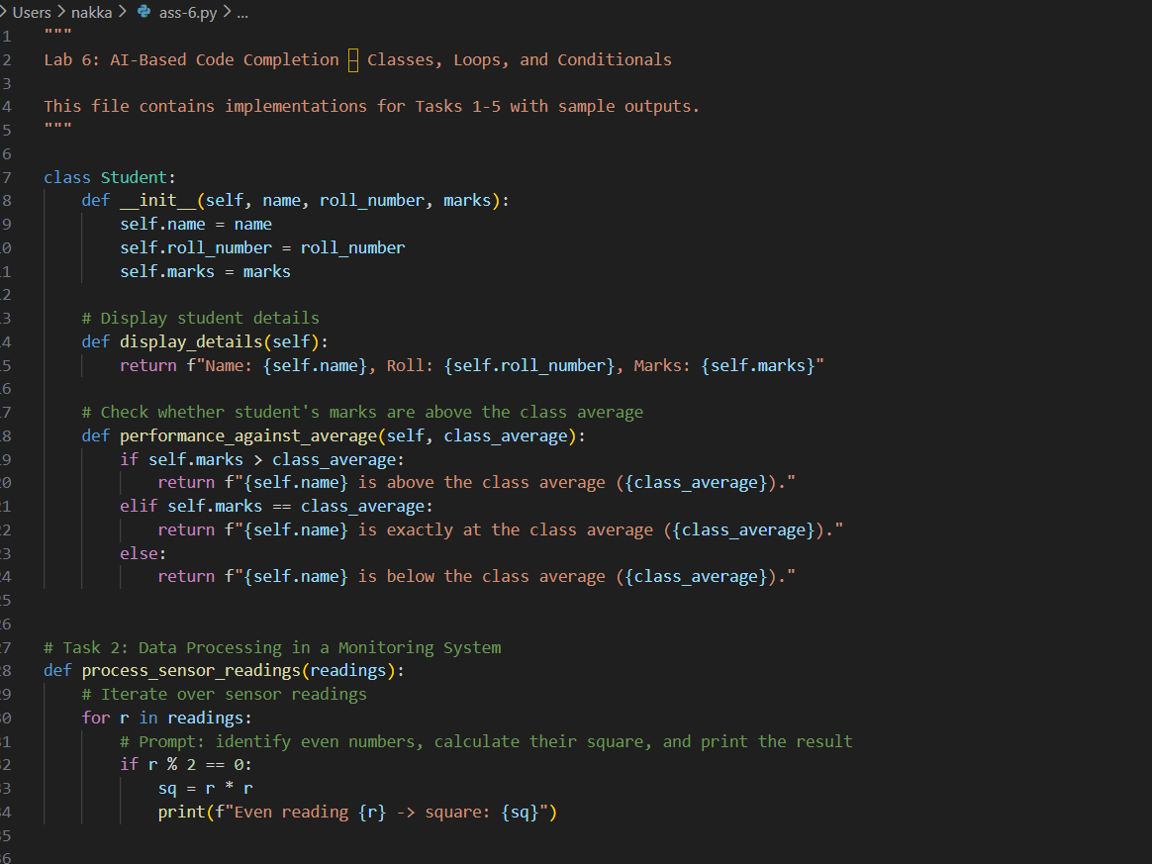

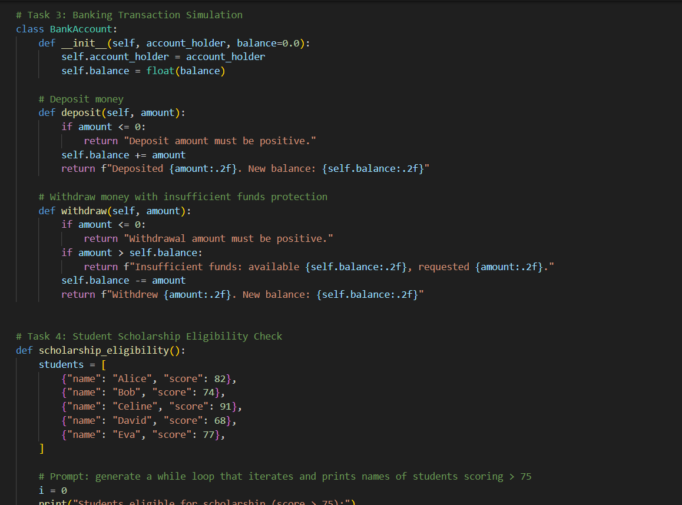

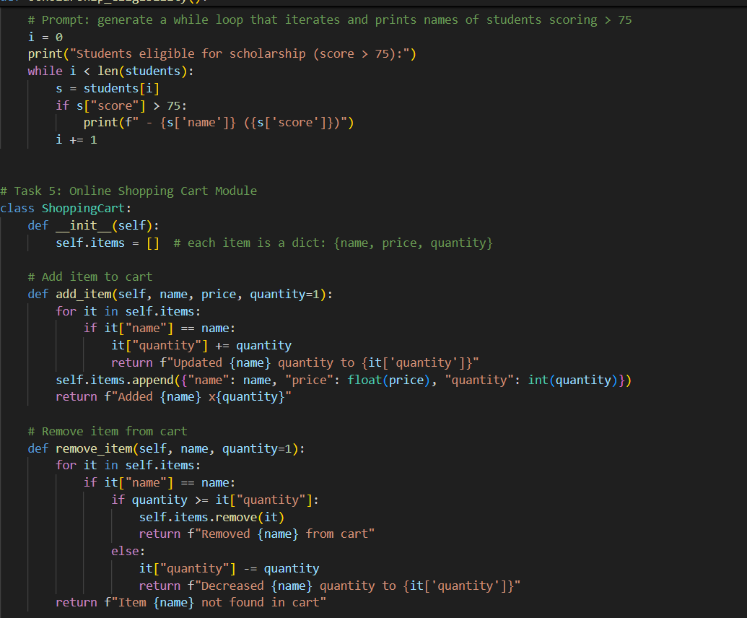

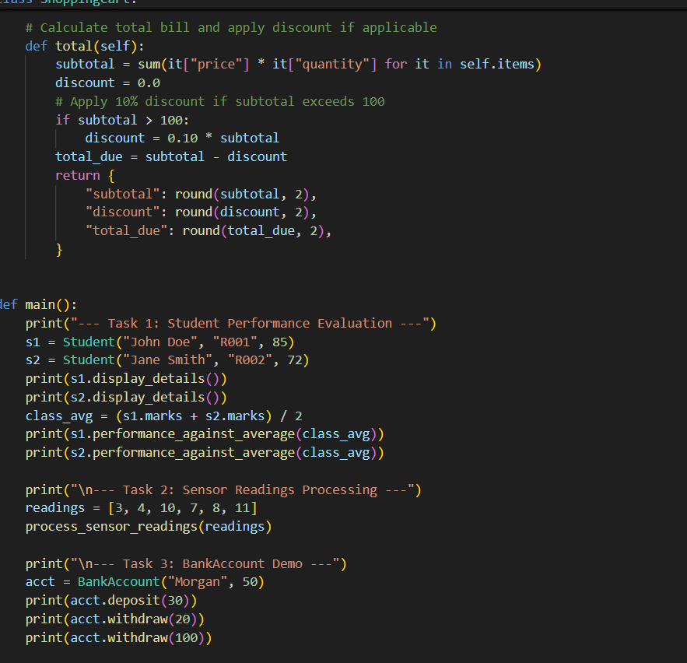

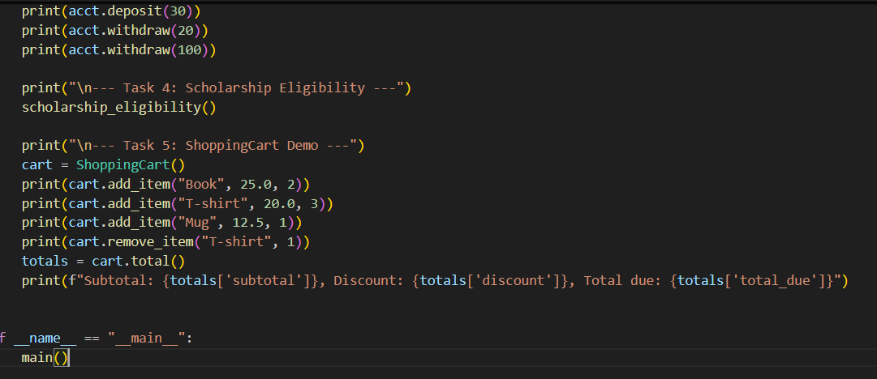

Output:
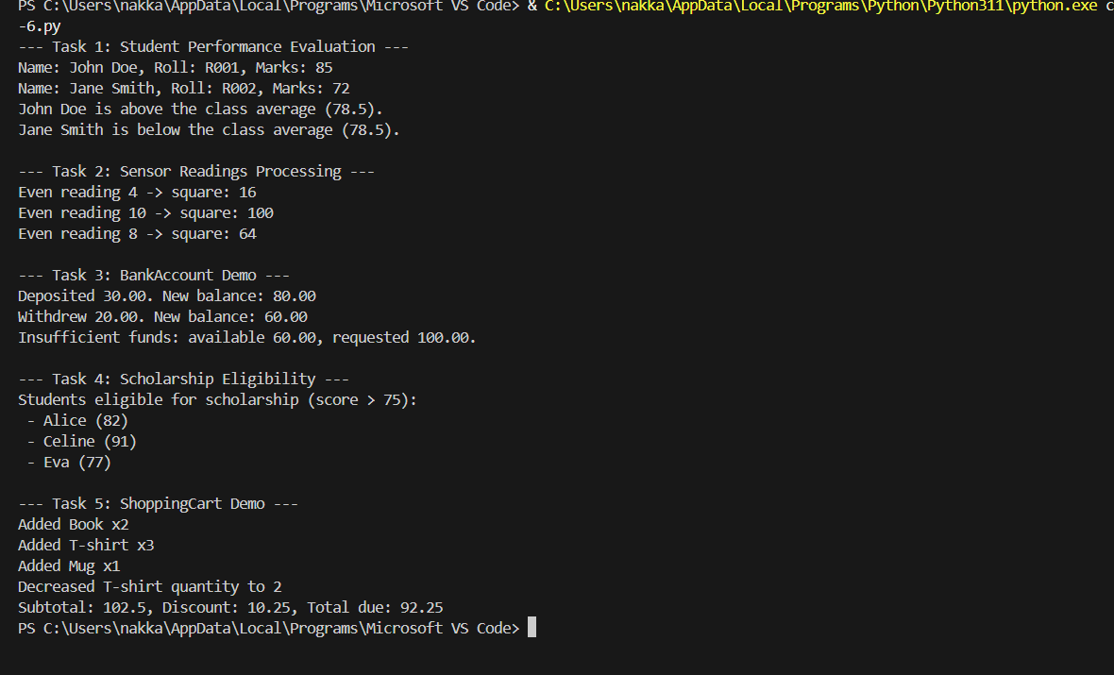

Analysis:
This assignment is all about how AI can assist in writing Python code using classes, loops, and conditions.
It also showed the importance of checking AI-generated code to make sure the logic is correct.
Each task is executed step by step.

